Fourier Series

EXPERIMENT - 7

CODE: -

clc

clear all

syms x

p=input('enter the period of the function f:');

l=p/2;

pr=input('enter the partition of [-l,l]or [0,2*l] as a vector');

f=input('enter the periodic function f as a vector:');

M=input('enter the  number of terms required in Fourier Series:');

for n=1:M

for i=1:length(pr)-1

    aa_0=int(f(i),x,pr(i),pr(i+1));

    aa(i)=int(f(i)*cos(n*pi*x/l),x,pr(i),pr(i+1));

    bb(i)=int(f(i)*sin(n*pi*x/l),x,pr(i),pr(i+1));

end

a_0=(1/l)*sum(aa_0);

a(n)=(1/l)*sum(aa);

b(n)=(1/l)*sum(bb);

end

for n=1:M

     F(n)=simplify(a(n))*cos(n*pi*x/l)+simplify(b(n))*sin(n*pi*x/l);

end

F_S=(a_0/2)+sum(F);

disp('The fourier series of the function f upto M number of terms is given by')

disp(simplify(F_S))

h1=ezplot(F_S,[0,2*[pi]);% graph of Fourier series of f in [-l l]

set(h1,'color',[0 1 0])

hold on

ezplot(f(1),[0,2*pi]) % graph of f in the first sub-interval

%hold on

%ezplot(f(2),[0,pi]) % graph of f in the second sub-interval

%hold on

%ezplot(f(3),[1,2]) % graph of f in the third sub-interval

%Change the lines 25-31 according to the given function.

Input 1: -

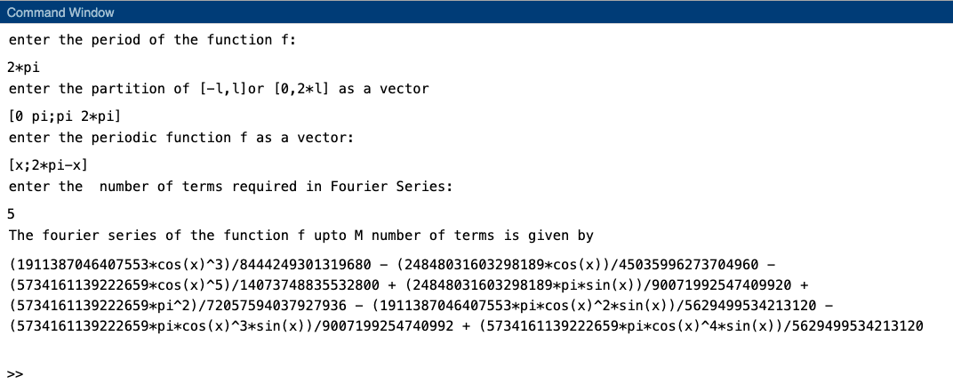

Graph: -

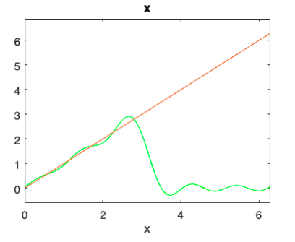

Input 2: -

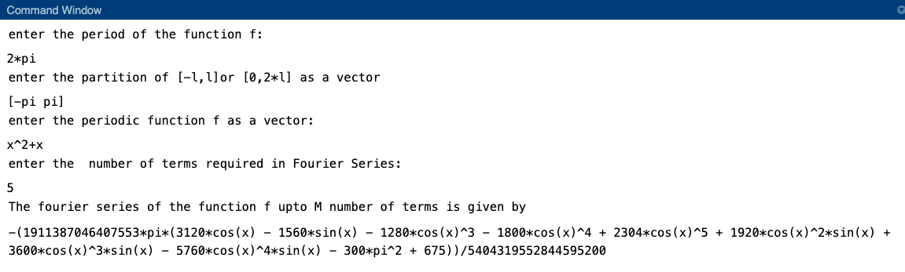

Graph: -

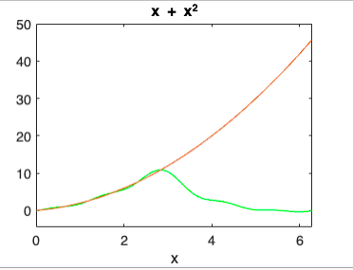

Input 3: -

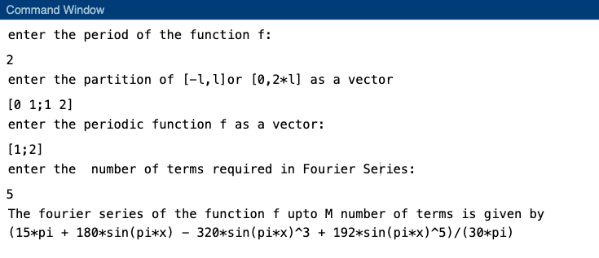

Graph: -

